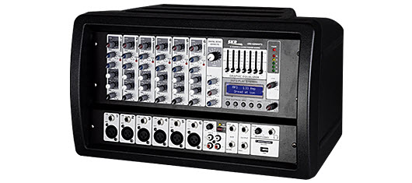

RMS Power 250W @ 4O
6 Channel Mic/Line
Digital effect stereo
MP3 Player System with USB and SDCARD Jack
Gold plated XLR and balanced line inputs
+48v Phantom power
Ultra-musical 2-band EQ on all channels
7 band EQ on all main output
Peak LEDs on all Channels
1 Aux Send per channel for external effects and monitoring
Highly accurate 5 segment Bargraph Meters
16 Level delay of the effect system inside
Track input assignable to master mix
Stereo headphone output
Rugged design power supply (120v or 220/230v) ensures superior signal integrity
Dimensions: 17 5/16” x 10 ¼” x 10 13/16” (440X260X275mm)
Weight: 24lb. (11Kgs.)

download

Link

http://www.skpaudio.com/por/products_detail.php?id=128

crx 626 mp3

